RUPANJANA KAR
518
12025052002537

Assignment 1
AI-Assisted Boolean Expression Simplifier — use GenAI to reduce a 4–6 variable expression (SOP/POS, K-map/algebraic), then implement and verify the simplified circuit in a simulator
Prompt:
Simplify the 4-variable Boolean expression $F(A,B,C,D) = \Sigma m(0, 2, 8, 10, 12, 14)$ using a Karnaugh map and provide the minimized SOP expression
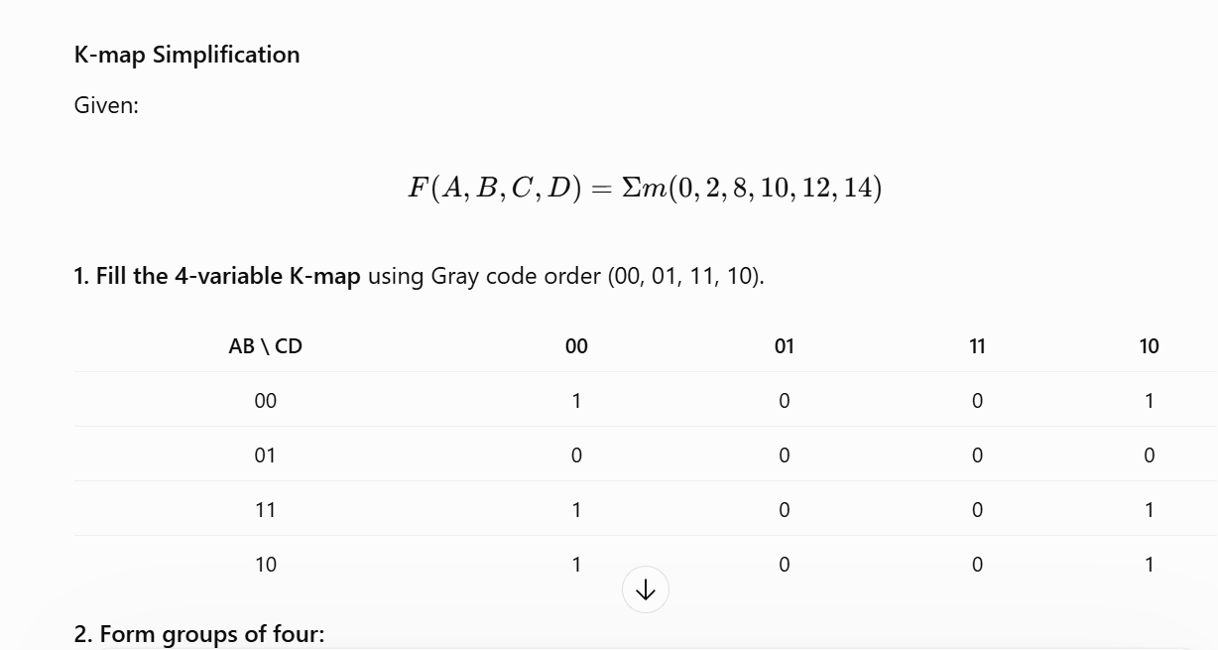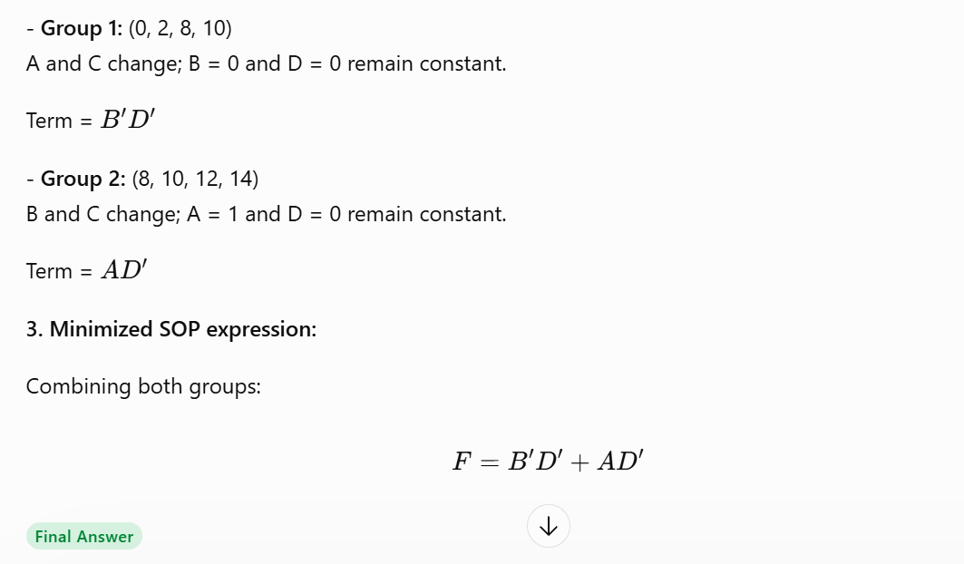

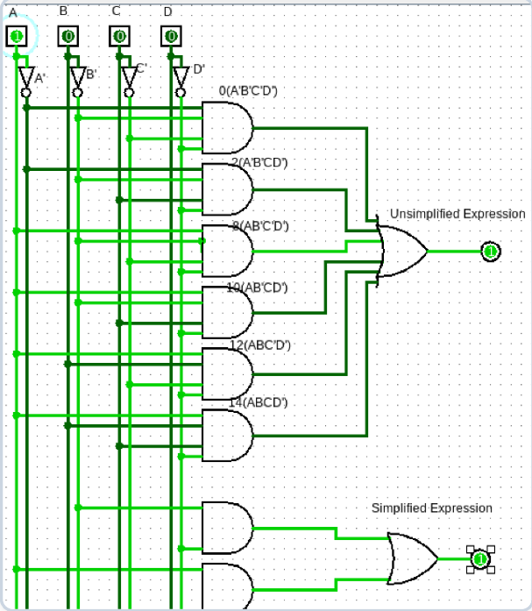
Discussion: The GenAI successfully minimized the 6-minterm Boolean expression into a simplified 2-term SOP expression (\(B'D' + AD'\)), reducing the overall logic complexity and number of gates required. It identified the optimal K-map groupings and provided the corresponding logic circuit, making implementation and verification in Logisim easier.

Assignment 2
Natural Language to Logic Circuit Generator — convert an English description of a logical situation into a Boolean expression and gate-level design using GenAI, then simulate and verify
Prompt:
Convert this English description into a Boolean expression and logic gate design: A secure vault opens (Output Y) only if the Master Key (A) is inserted AND either the Manager PIN (B) is correct OR the Biometric scan (C) is successful
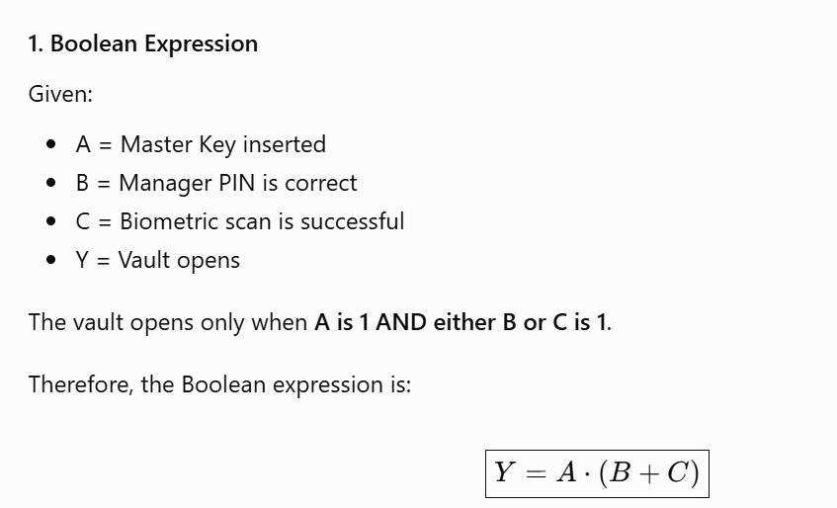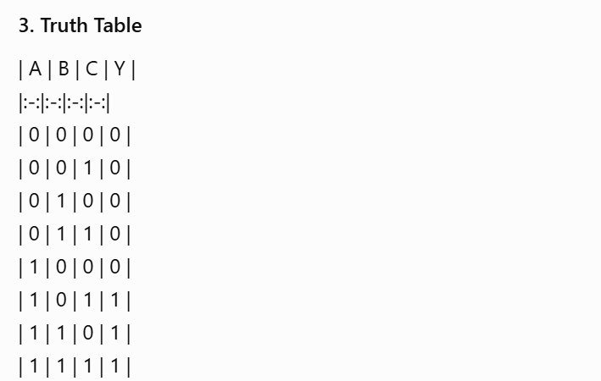
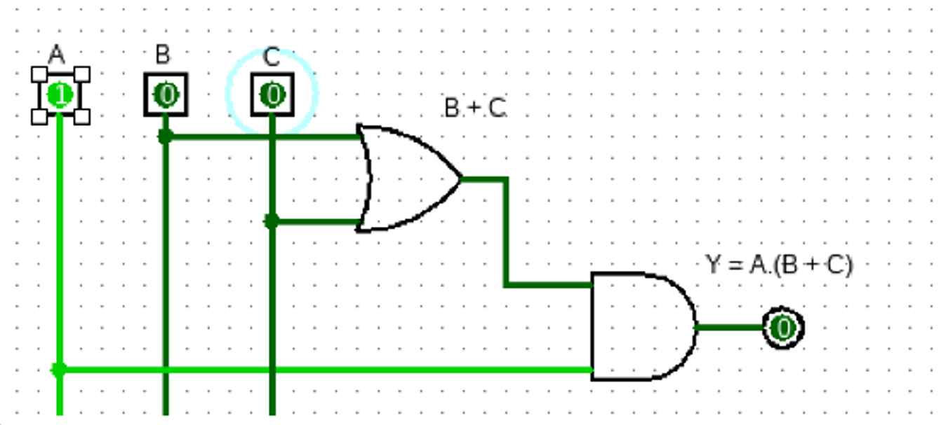
Discussion: GenAI converted the given security conditions into the Boolean expression \(Y=A(B+C)\). It identified the OR and AND gate combination required, generated the corresponding logic circuit, and provided a truth table to verify the output for all eight possible input combinations.

Assignment 3
FSM Design for Traffic Light Controller using GenAI — use GenAI to generate the state diagram/table/logic equations for a 3-light + pedestrianrequest FSM; implement with flip-flops and simulate
Prompt:
Generate a state transition table and D flip-flop logic equations for a Moore FSM traffic light controller with 3 states (00-Green, 01=Yellow, 10-Red) and one pedestrian-request input (P). The light transitions from Green to Yellow if P=1; otherwise, it stays Green. Yellow and Red states transition automatically to the next state.
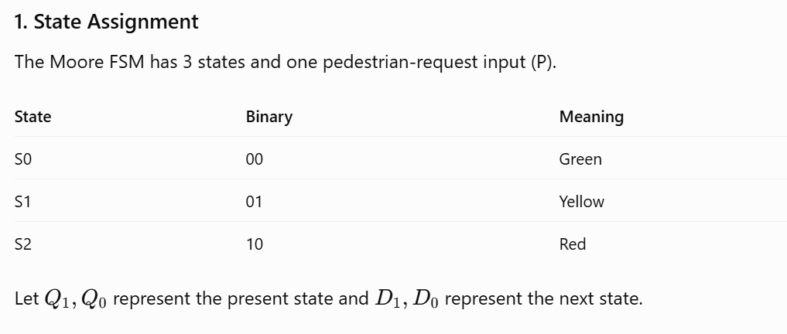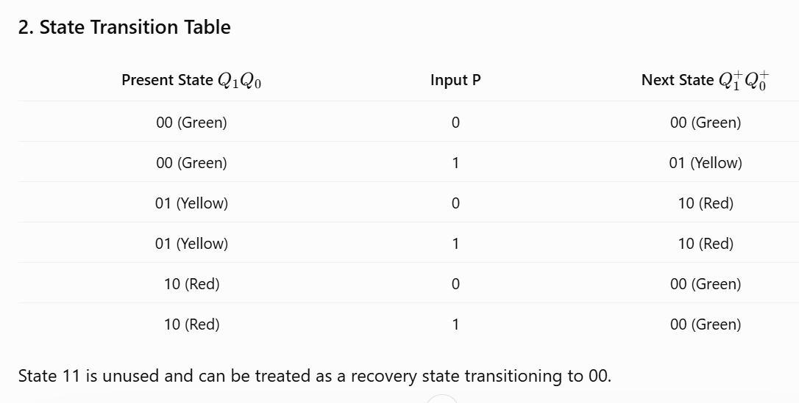
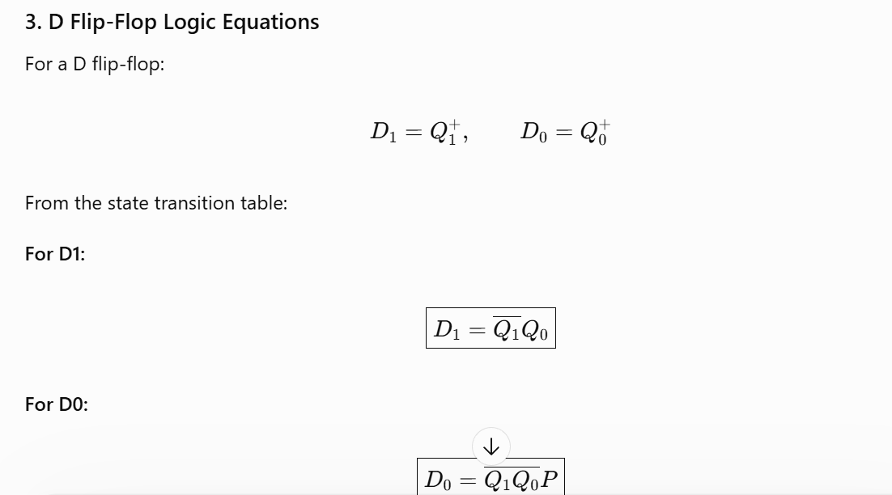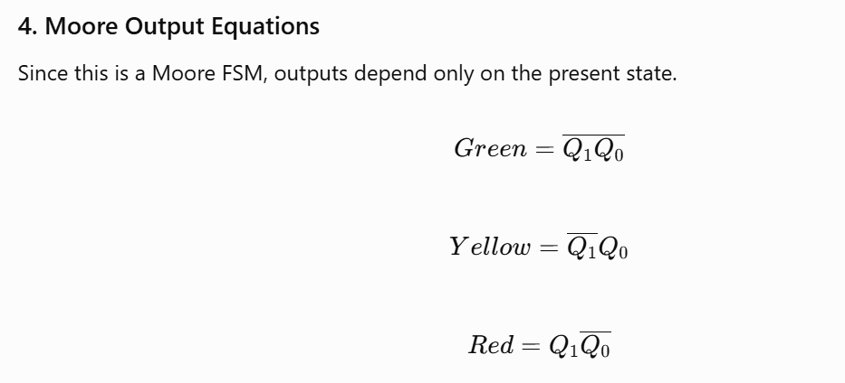
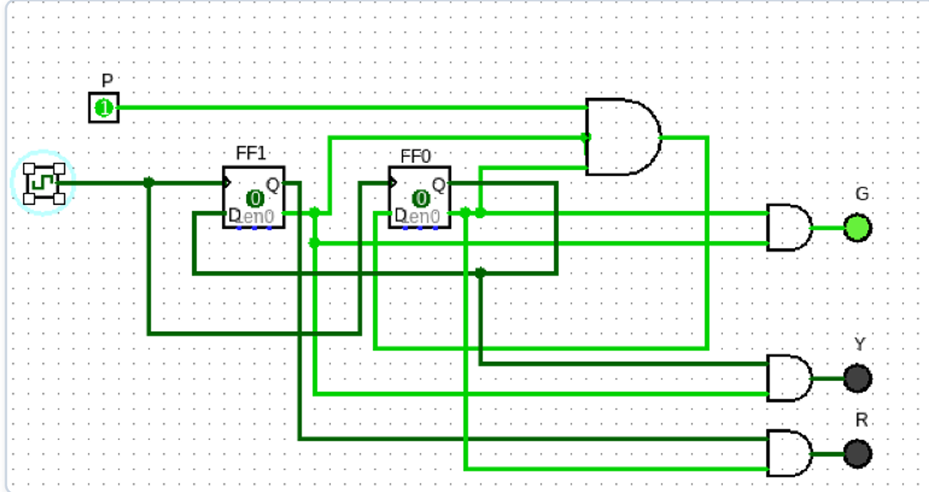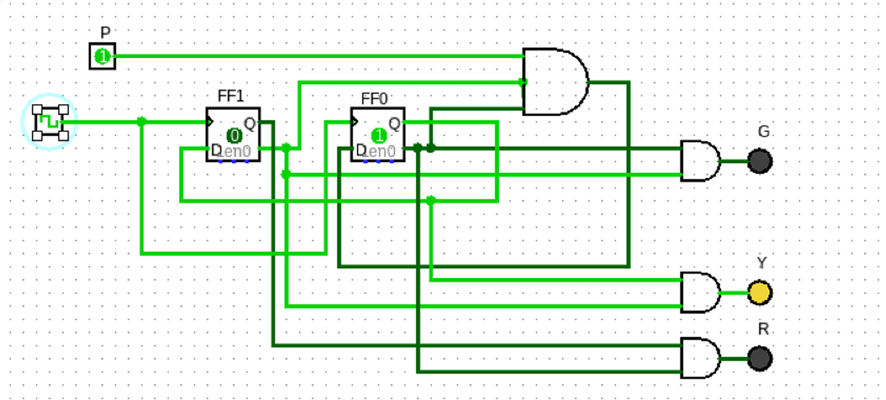
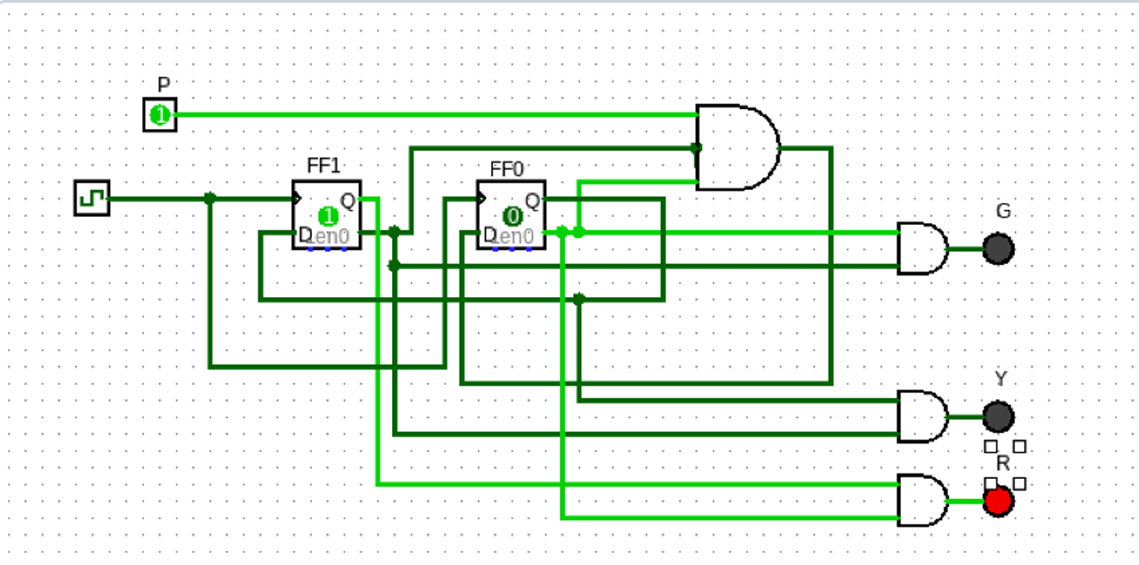

Discussion: Generative AI helped translate the traffic light controller requirements into a three-state Moore FSM and construct the corresponding state transition table for both values of the pedestrian input. It derived the minimized D flip-flop input equations (\(D_1=\overline{Q_1}Q_0\) and \(D_0=\overline{Q_1}\overline{Q_0}P\)) and identified the logic gates required for circuit implementation.

Assignment 4
AI-Based Fault Detection in Digital Circuits — design a deliberately faulty circuit (e.g., a Full Adder with an error), have GenAI diagnose the fault from the truth table, then correct and re-verify
Prompt:

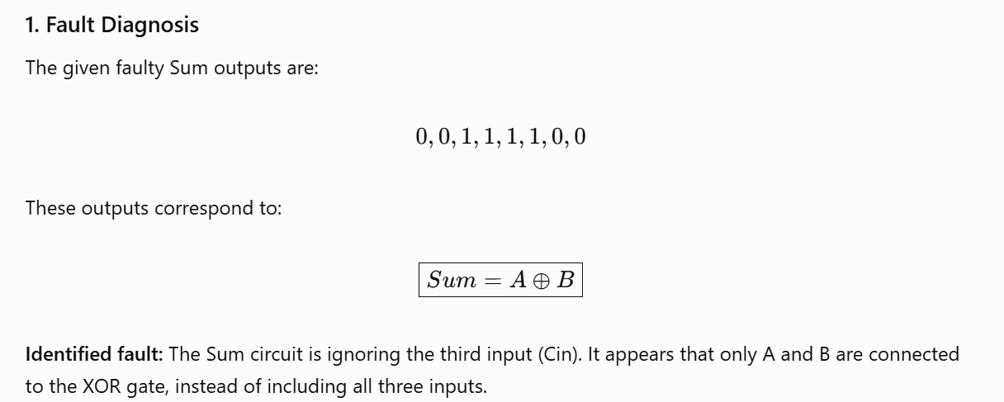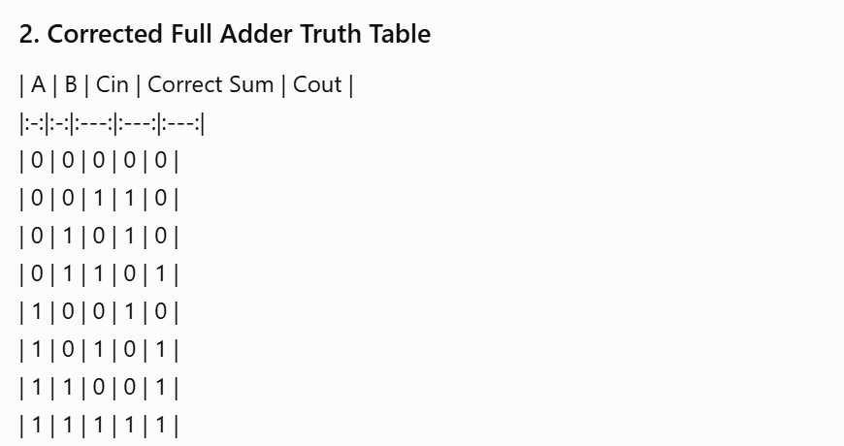
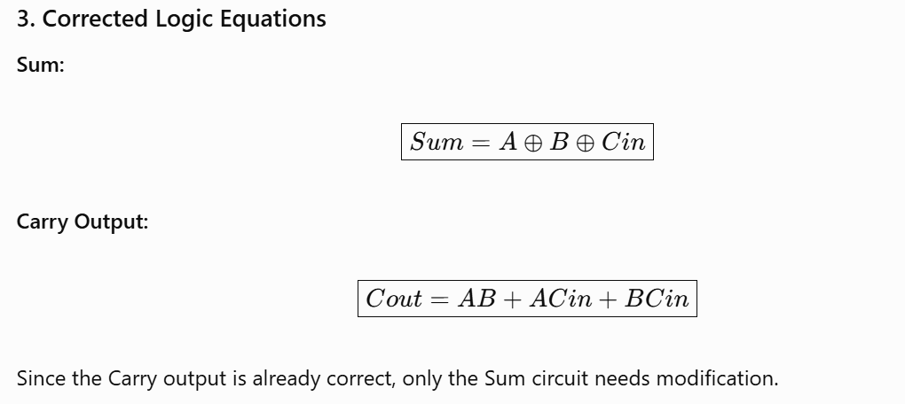
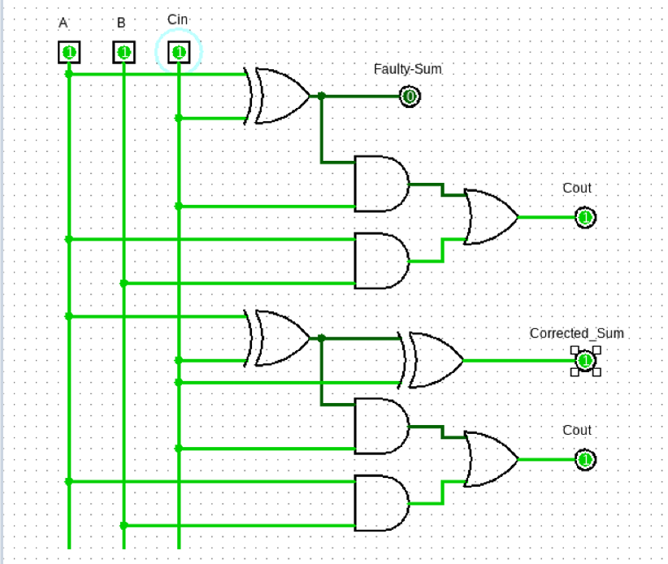
Discussion: Generative AI helped identify that the faulty Sum outputs correspond to \(A\oplus B\), indicating that the carry-in input was omitted from the XOR operation. It provided the corrected three-input XOR expression, verified the full adder truth table, and suggested the necessary circuit modification while retaining the correct Carry output.

Assignment 5
Digital Clock FSM Design with GenAI — use GenAI to derive FSM states and flip-flop-based implementation for a 24-hour digital clock; simulate and verify seconds/minutes/hours counting
Prompt:
Derive the FSM states and modular counter logic for a 24-hour digital clock using flip-flops
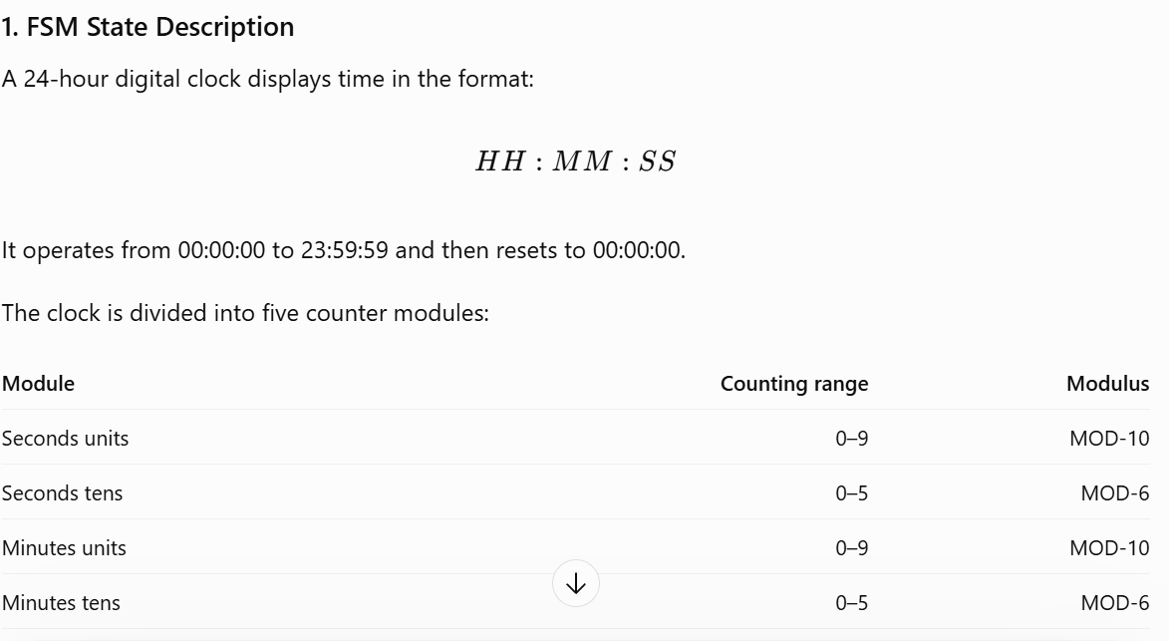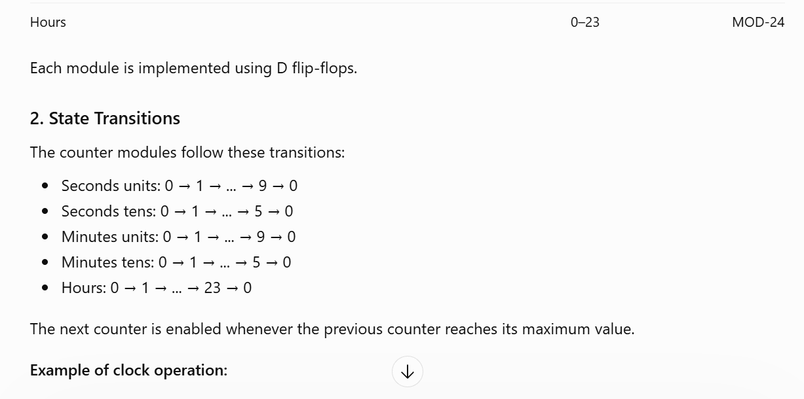
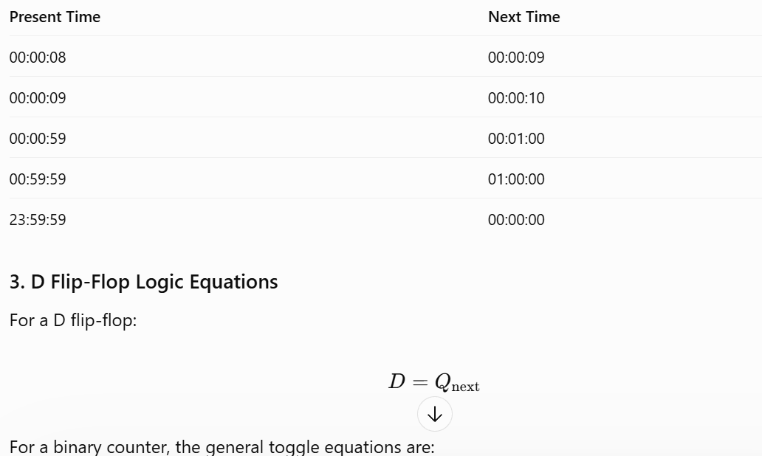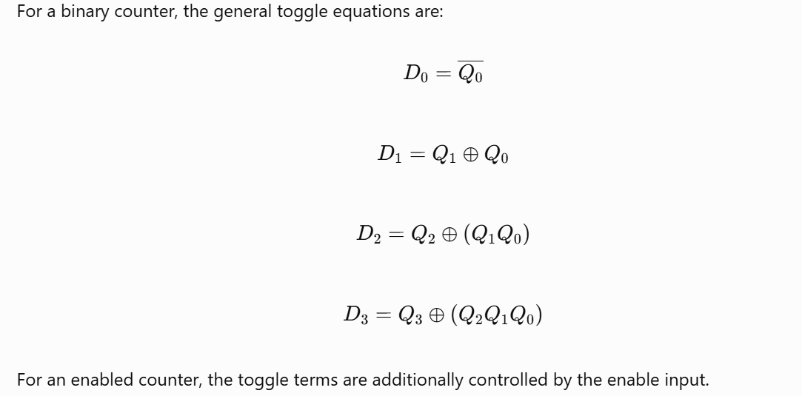

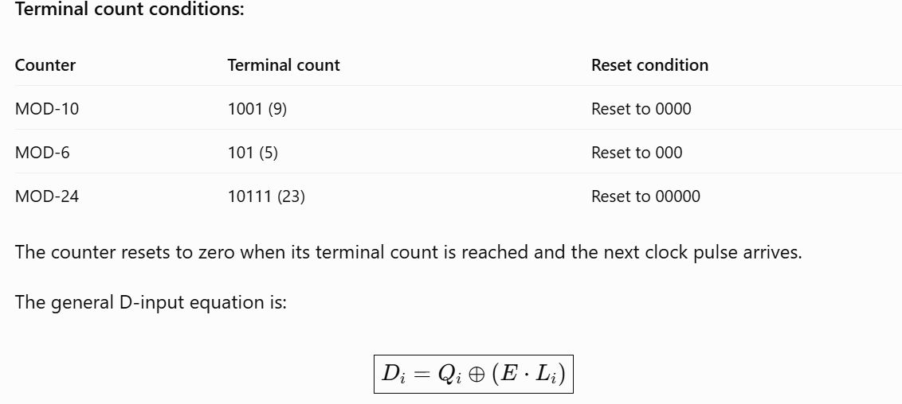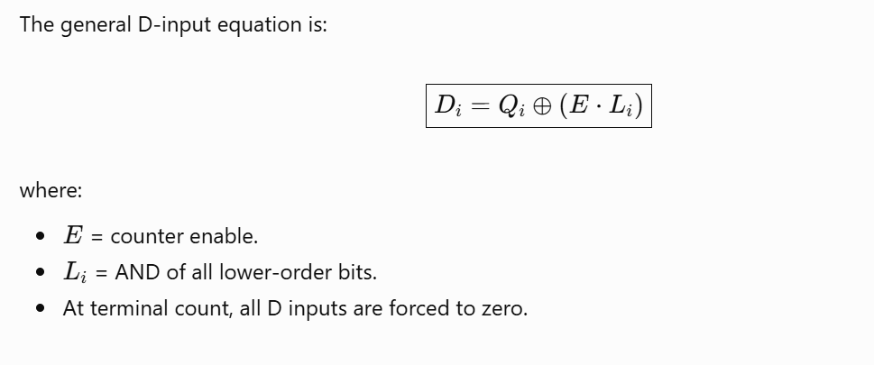

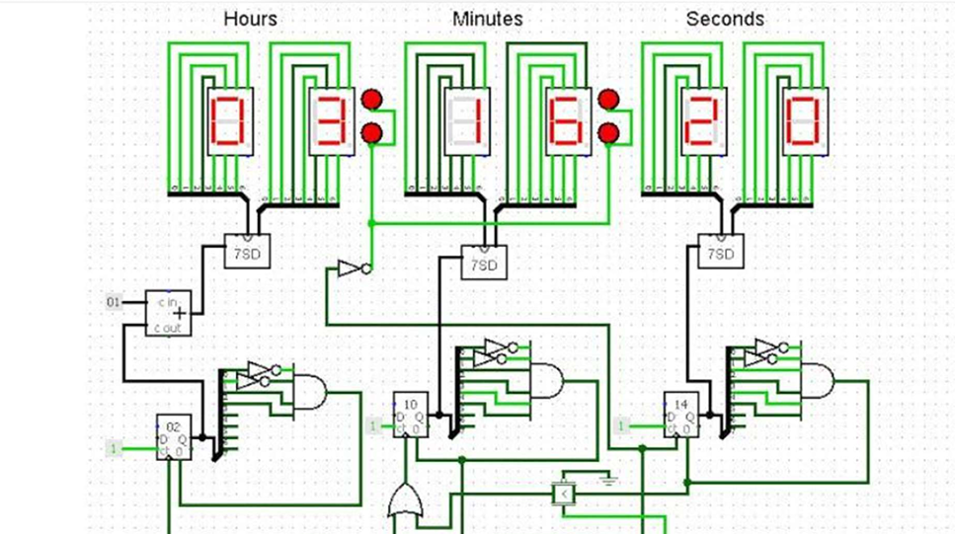
Discussion: Generative AI helped divide the 24-hour digital clock into MOD-10, MOD-6 and MOD-24 counter modules and identify their respective counting sequences and terminal states. It derived the D flip-flop next-state equations, identified the rollover conditions and explained how the counter modules can be cascaded to achieve automatic transitions from seconds to minutes and hours.

Assignment 6: Application Mapping of Sequential Building Blocks
1. Flip-Flop – 1-Bit Memory Cell
System & Justification: A D Flip-Flop is the fundamental bistable storage element used in digital systems. Every register inside a microprocessor (e.g., x86, ARM) is built from multiple flip-flops, where each flip-flop stores one bit of information (0 or 1). It captures input data at the rising edge of the clock and holds the value stably until the next clock pulse. Another practical application is a keypad debounce circuit that eliminates mechanical contact noise.
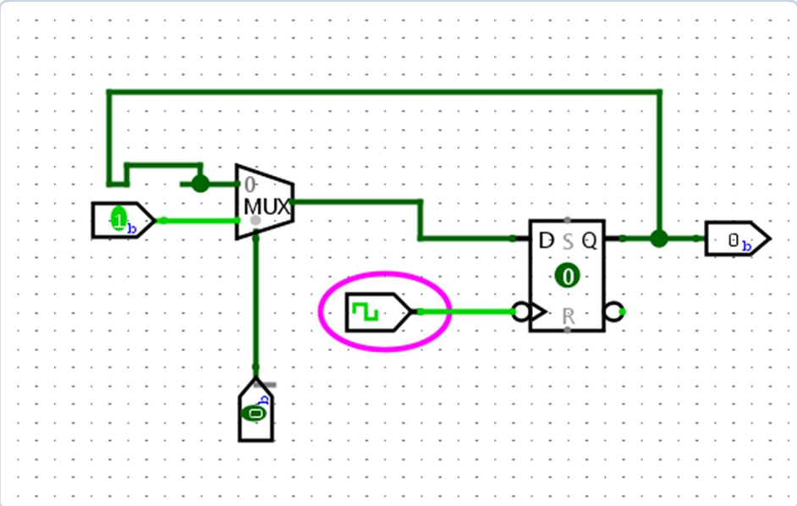
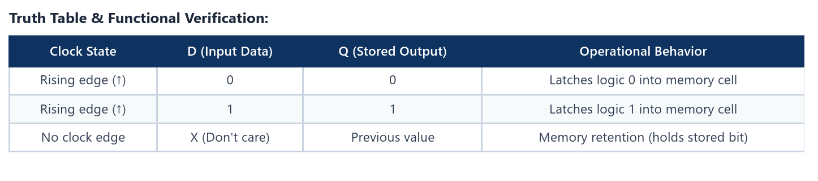
2. Mod-60 Counter – Digital Clock Timebase
System & Justification: A Mod-60 counter counts pulses sequentially from 0 to 59 and automatically resets to 0. It is realized using six flip-flops (Q5..Q0) and an active reset detection circuit. In digital clocks, it forms the seconds and minutes counting modules. It is also used as a frequency divider to divide 60 Hz down to a 1 Hz clock pulse.
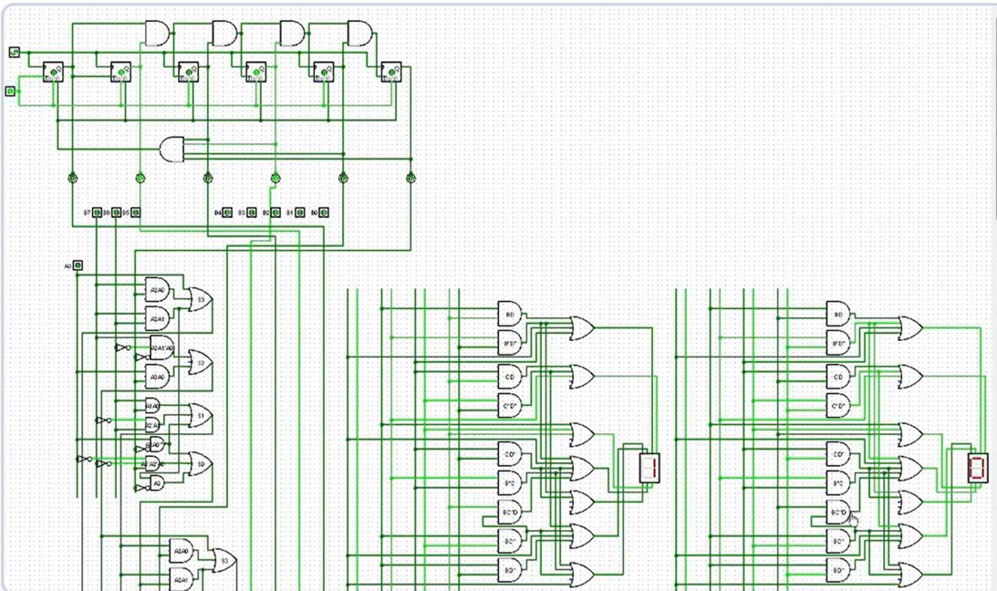
Counting Sequence & Reset Condition: The counter increments through 0 to 59 (binary 1110112). When count 60 (1111002: Q5=1, Q4=1, Q3=1, Q2=1, Q1=0, Q0=0) is reached, the AND-gate reset logic triggers an instantaneous reset to 0:
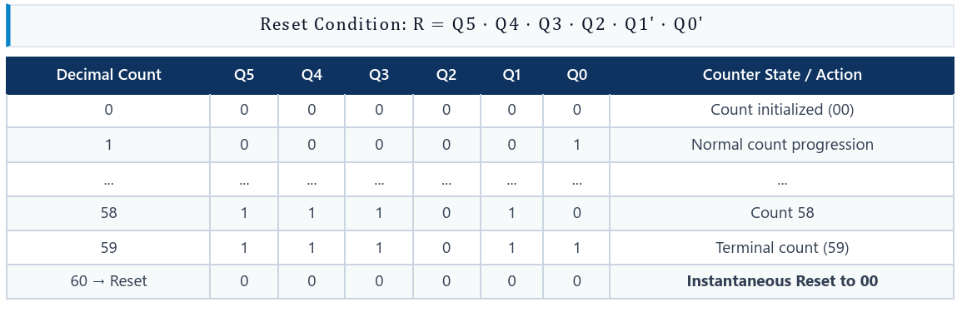
3. Shift Register – Serial Communication
System & Justification: Shift registers perform vital serial-to-parallel (SIPO) and parallel-to-serial (PISO) conversion. They enable high-speed data transmission over a single pair of wires in UART, SPI, and USB protocols, and allow microcontrollers to drive multi-digit LED displays (e.g., via 74HC595) using minimal I/O pins.
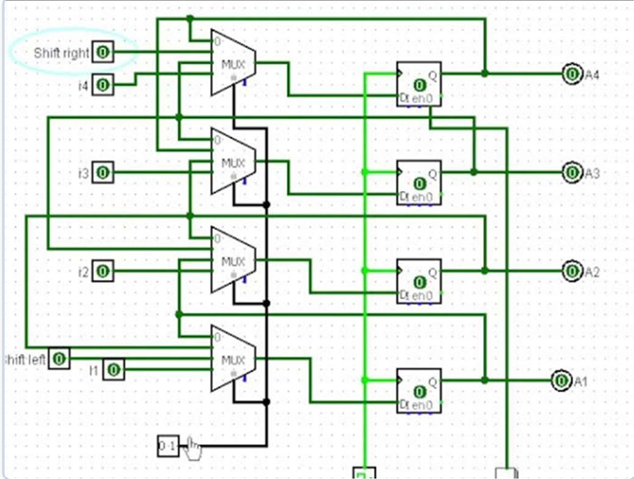
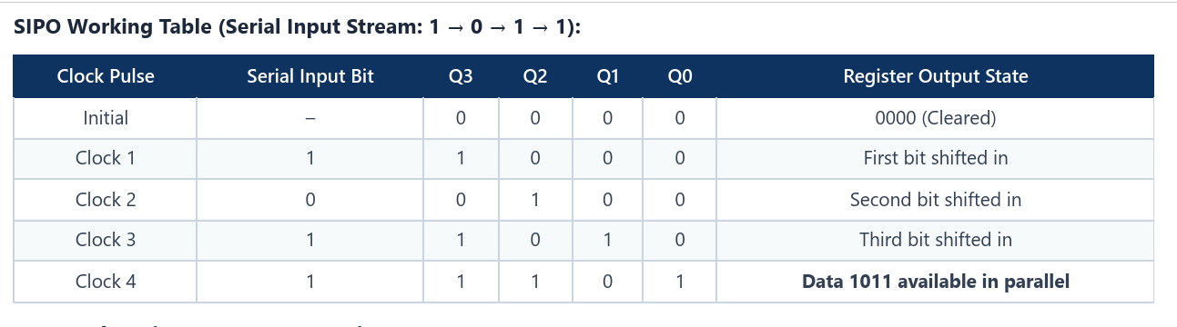
Discussion: The shift register successfully performed serial-to-parallel conversion without data loss. The simulated parallel output matched the sequentially generated input sequence, verifying its utility in translating single-wire lot sensor data into parallel formats.

Lab Assignment 7: Design a Mini Automation System
Abstract & Objective:
This project presents an automatic parking barrier control system designed using a Finite State Machine (FSM), D Flip Flops, and logic gates. The system automatically detects approaching vehicles and verifies payment confirmation before opening the parking barrier. Once the vehicle clears the gate, the barrier closes automatically.
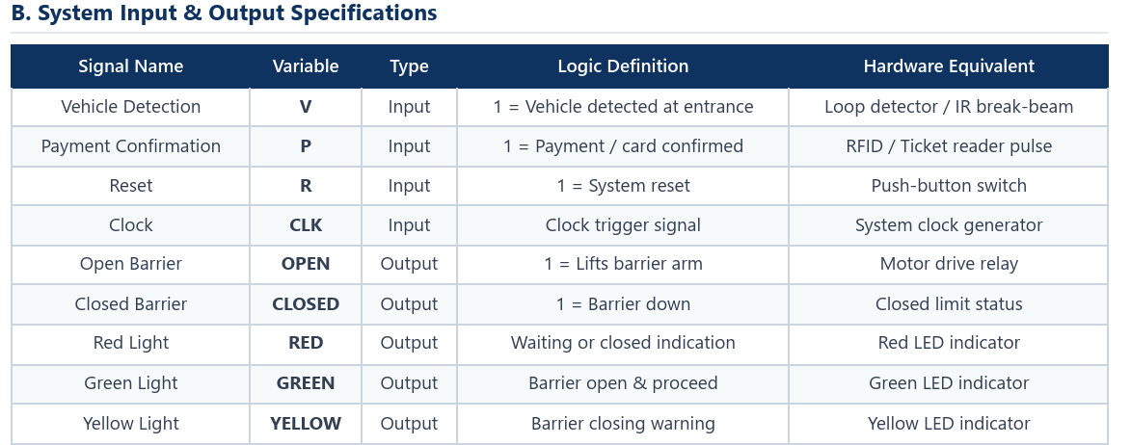
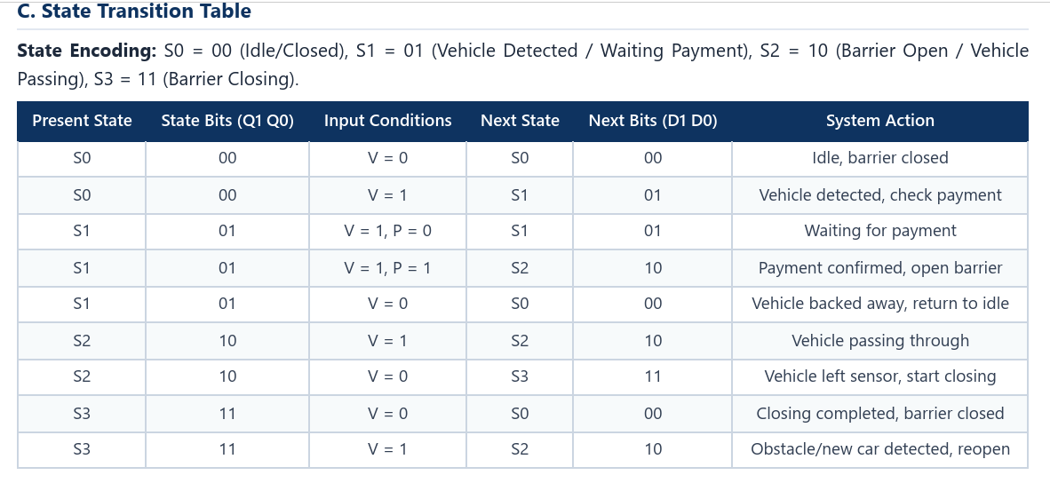
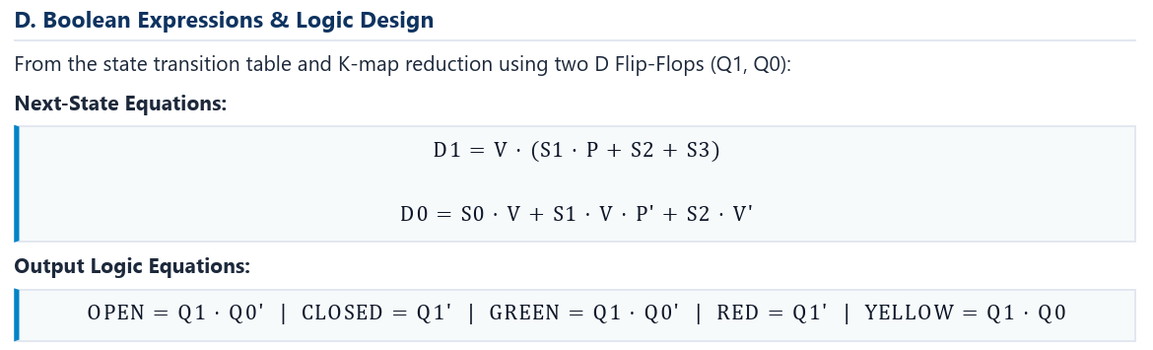
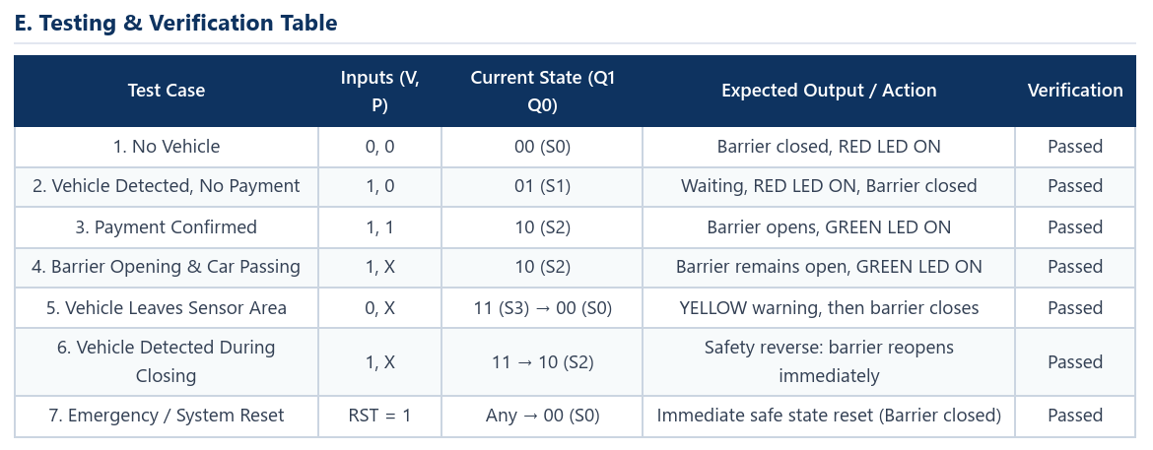
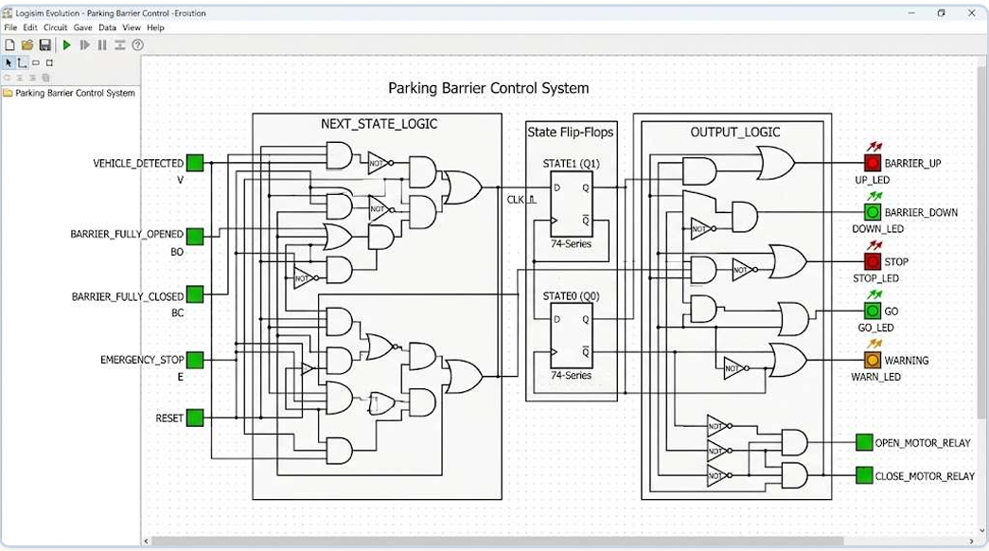
Discussion: The simulation confirms that the barrier opens strictly after successful payment confirmation (P=1). It remains safely open while the vehicle traverses the detection area (V=1) and initiates closing only when the vehicle has cleared (V=0). A safety sensor check prevents the arm from lowering if an obstruction is re-detected during closing.
Experiment 8: From Code to Circuit: Building a 4-Bit Mini-ALU and Program Counter
1.Abstract & Objective:
Abstract: This report presents the hardware design and software mapping of a 4-bit Mini-ALU and a 4-bit synchronous Program Counter (Up-Counter) in Logisim Evolution. The project demonstrates how high-level software code constructs map directly onto foundational digital hardware components.
Objective: Design and simulate a 4-bit ALU and a 4-bit synchronous up-counter. Map high-level programming constructs (arithmetic operations and loop control counters) to physical datapath and control hardware blocks.
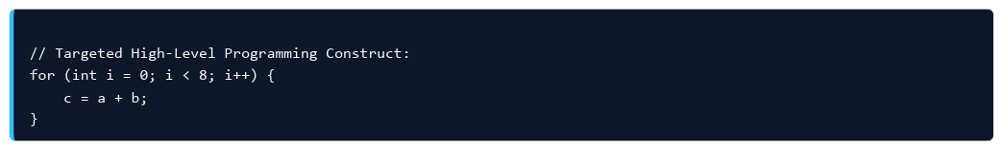
2. Part 1: 4-Bit Mini-ALU & Register File
Datapath The 4-bit ALU utilizes an Adder component with mode-controlled XOR gates on input B to perform both addition (M = 0) and subtraction (M = 1) via 2's complement arithmetic (A + B' + 1). The datapath register file uses D Flip-Flops and multiplexers to provide operand registers and destination write-back.
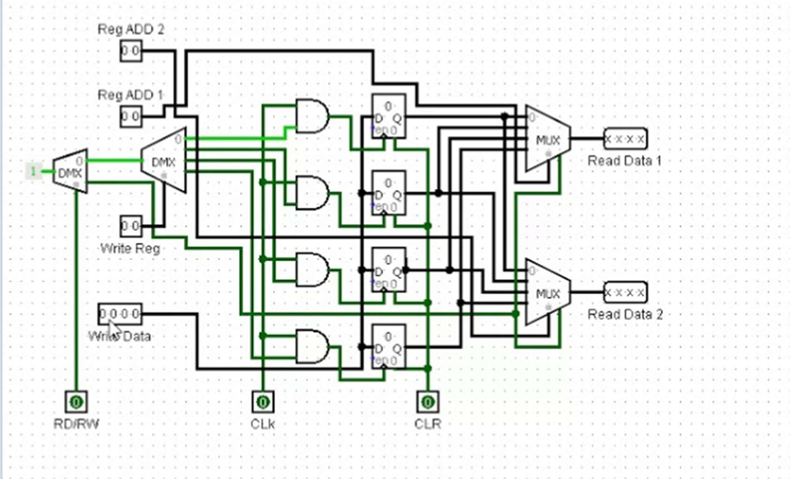
3. Part 2: 4-Bit Program Counter (Up-Counter)
The Program Counter (PC) is constructed using four D Flip-Flops (A, B, C, D) connected to a common clock and reset line, incorporating increment logic controlled by an Enable pin. On each instruction cycle, the PC increments to address the next software instruction.
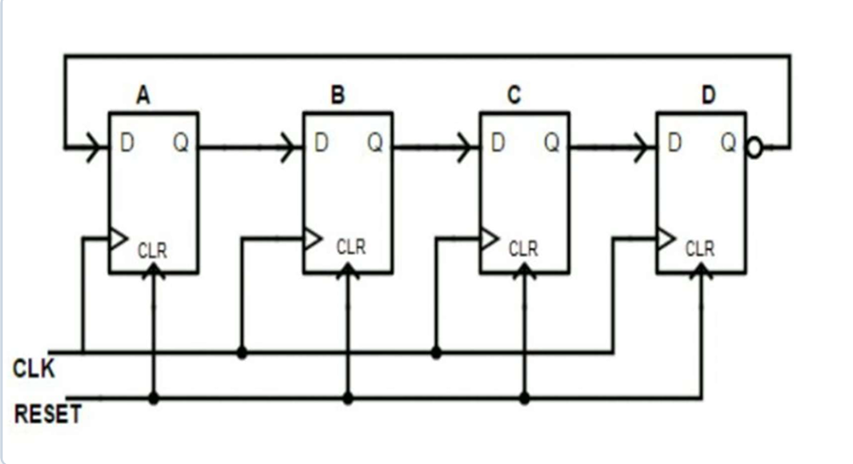
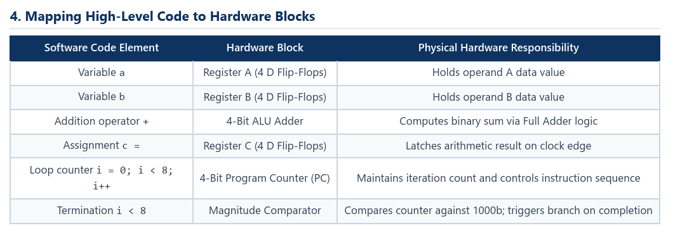
5. Simulation Steps & Verification
1. ALU Verification: The simulation hand tool was used to toggle operands A and B with Mode M = 0 and M = 1, verifying addition and subtraction across all 4-bit vectors.
2. PC Verification: Clock pulses were triggered, observing sequential advancement from 00002 to 01112 (8 loop cycles) before termination.
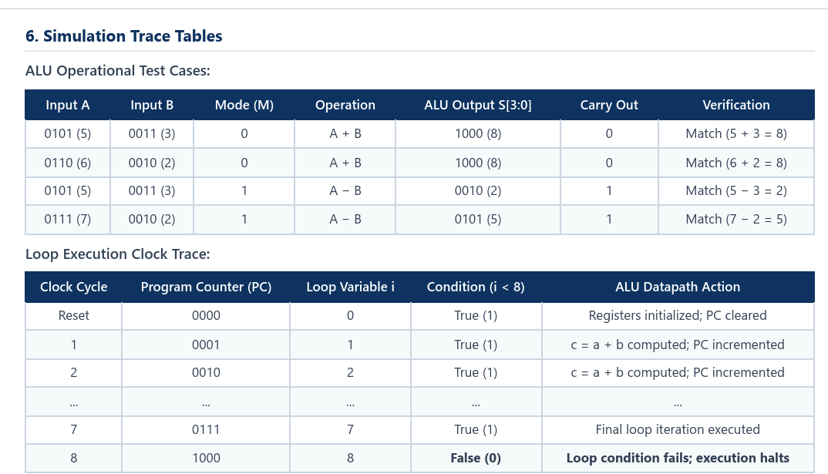
Discussion: The 4-bit Mini-ALU and Program Counter were successfully designed, simulated, and mapped to software loop structures in Logisim Evolution. This experiment successfully fulfills Course Outcome CO4 by bridging highlevel programming logic with underlying digital hardware architecture.

Experiment 9: AI-Assisted Code-to-Gate Explainer
1. Objective
AI Tool: ChatGPT To use Generative AI to understand how a high-level software code snippet can be translated and implemented using discrete digital hardware components, verify truth-table equivalence in Logisim Evolution, and evaluate the AI-generated architecture.
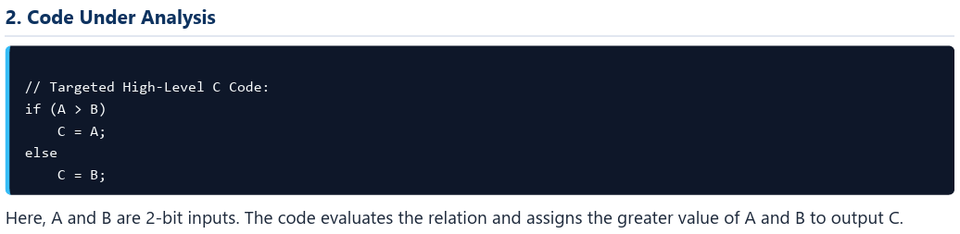
3. Hardware Components Identified by GenAI
2-Bit Magnitude Comparator: Compares inputs A (A1 A0) and B (B1 B0) and produces an active-high relational output A > B.
Two 2:1 Multiplexers: Select either bit A or bit B for each output bit: First MUX → selects A1 / B1 → produces C1 Second MUX → selects A0 / B0 → produces C0
Control Logic: The comparator's A > B output drives the select pin (Sel) of both multiplexers simultaneously. If A > B = 1, the MUXes select input A; otherwise, they select input B.
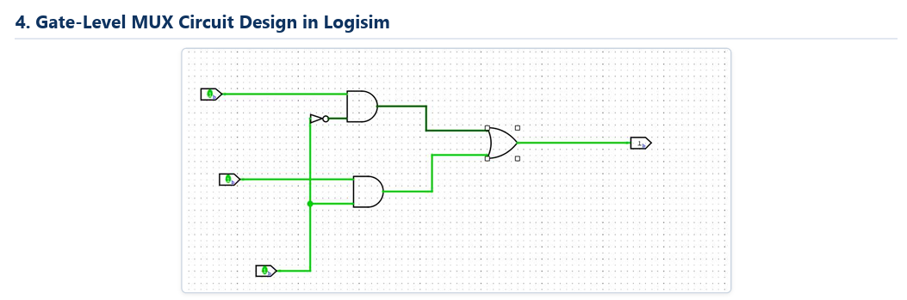
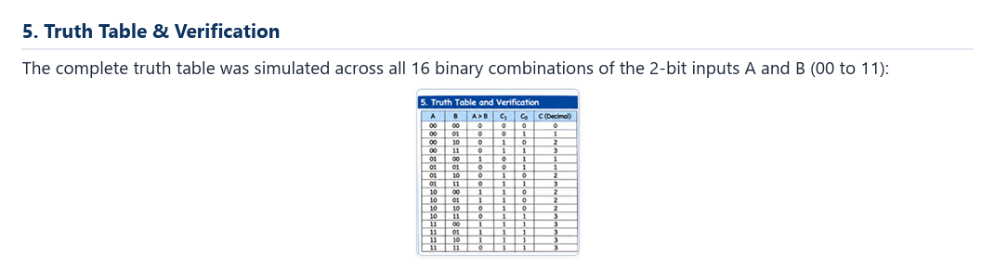
6. AI Analysis & Critical Reflection
What GenAI Identified Correctly: Accurately recognized that a conditional branch maps to a Comparator + Multiplexer datapath, using the comparison flag directly as the select line.
Human Engineering Correction: Real hardware requires synchronous input/output latching to eliminate transient glitching, and explicit bit-slice multiplexing per data bit (C1, C0).
7. Result & Conclusion
Result & Conclusion: The circuit correctly outputs \(\max(A, B)\) across all 16 input combinations, proving hardware equivalence to the C conditional construct. The comparator performs relational evaluation while multiplexers perform data steering.

